MITHIBAI COLLEGE
Department of Computer Science
BSC-II sem –III (2026-27)
__________________________________________________________________________Practical-7 Implementing Files and AWT
Date: -05/09/2026 Submission Date: - 12/09/2026
Write-up:
- File I/O
- 5 input and output classes
- Steps of read and writing a file
- AWT
- Frame vs Panel
- Layout managers
- Any 5 types of Layout managers
- Steps of creating GUI apps
- AWT (any 7 components)

- Create a new Java note “JavaFile1.txt” (enter the given text from the console and save it to this file)
Java is an object-oriented programming language.
It supports encapsulation, inheritance, and polymorphism.
File handling in Java allows for efficient reading and searching of text.
Keep learning and mastering Java!
- Read the content of Java note “JavaFile1.txt” and copy it to “JavaFile2.txt” using file streams.
- Create a program that counts the number of lines, words, and characters in a given text file.
- Create a program that searches for a specific word in a file and prints its occurrences.
- Design the following using awt :

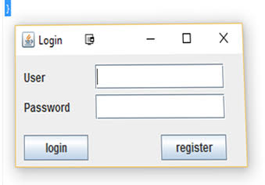

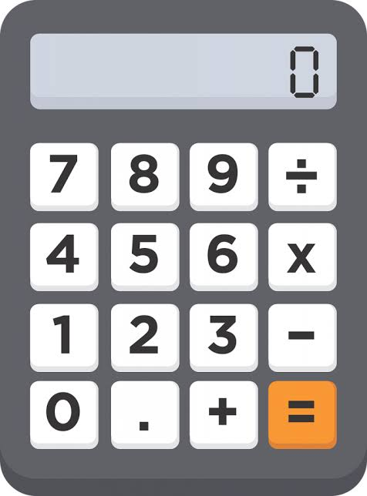

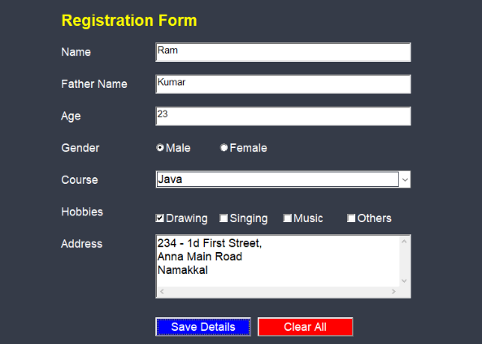

**********till next Friday only****************good luck******be your own*********

